

SQL_02 - [Functions, Filtering and Subqueries](https://www.scaler.com/academy/mentee-dashboard/class/71191)

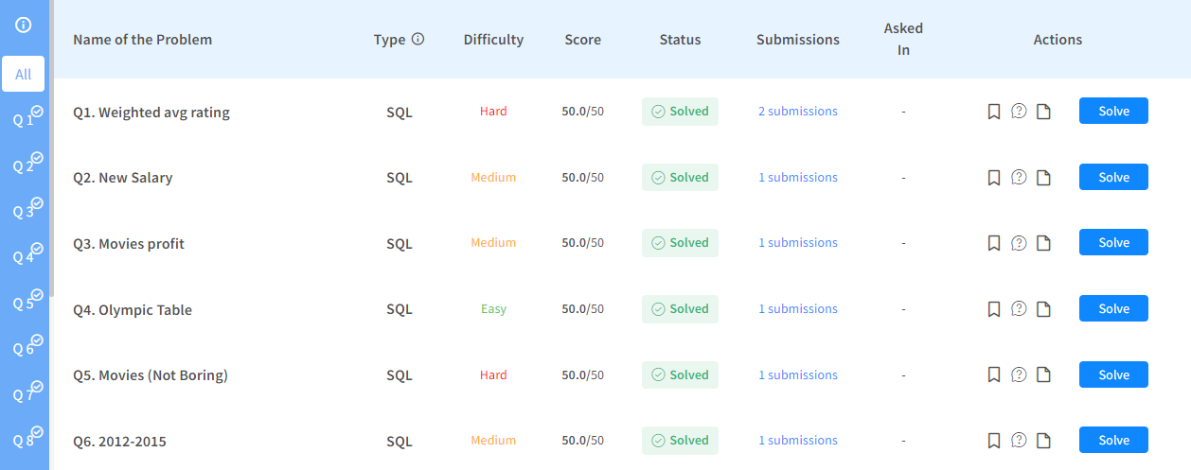

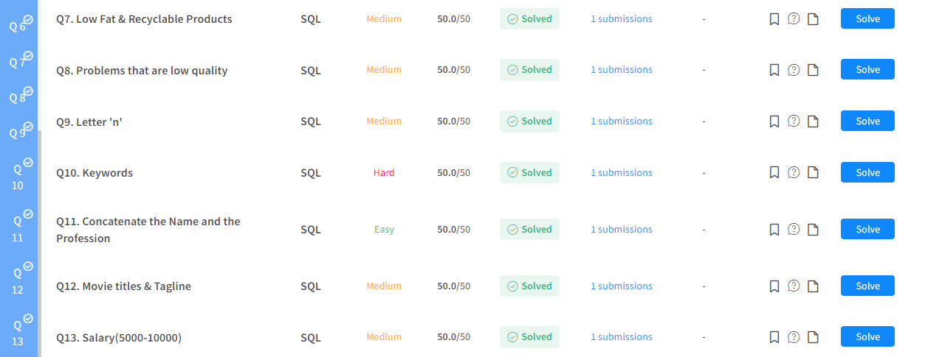

Q1. Weighted avg rating

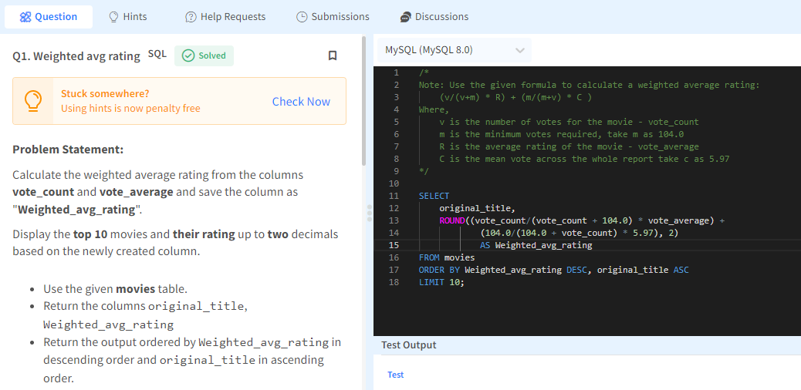

**Dataset description for movies table:**

1) id - tmdb movie id

2) imdb_id - imdb movie id

3) popularity -A numeric quantity specifying the movie's popularity.

4) budget -The budget in which the movie was made.

5) revenue - The worldwide revenue generated by the movie.

6) original_title- The title of the movie

7) cast - The name of the lead and supporting actors.

8) homepage - A link to the homepage of the movie.

9) director - The name of the director of the movie

10) tagline - Movie's tagline.

11) keywords -The keywords or tags related to the movie.

12) overview -A brief description of the movie.

13) runtime -The running time of the movie in minutes.

14) genres -The genres of the movies

15) production_companies-The production house of the movie.

16) release_date -the date on which it was released.

17) vote_count -the count of votes received.

18) vote_average - average ratings the movie received.

19) release_year - the year on which it was released

Q2. New Salary

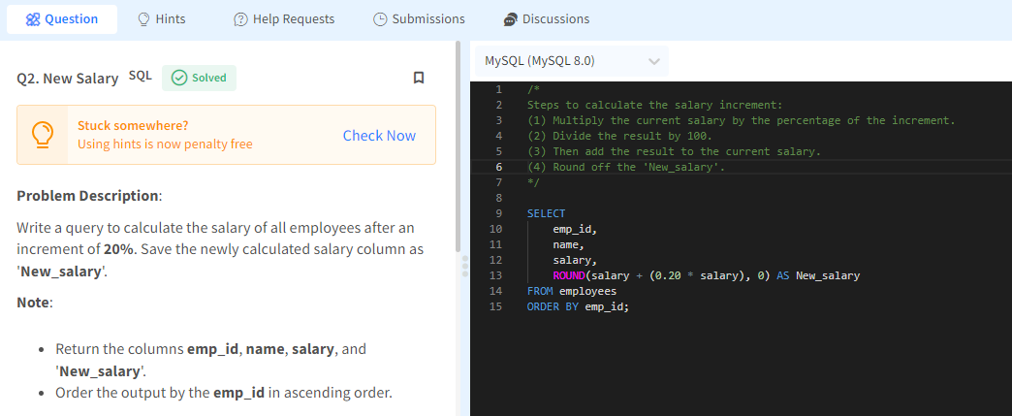

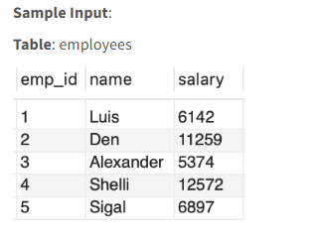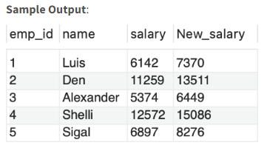

Q3. Movies profit

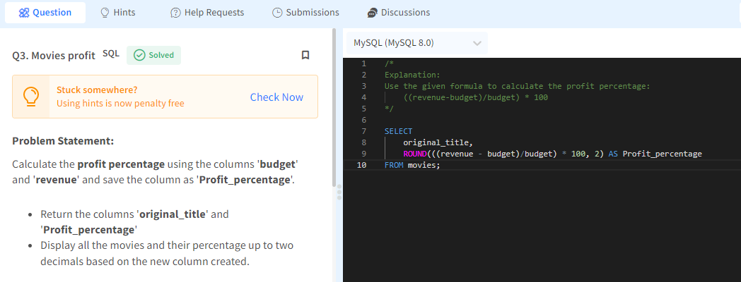

Q4. Olympic Table

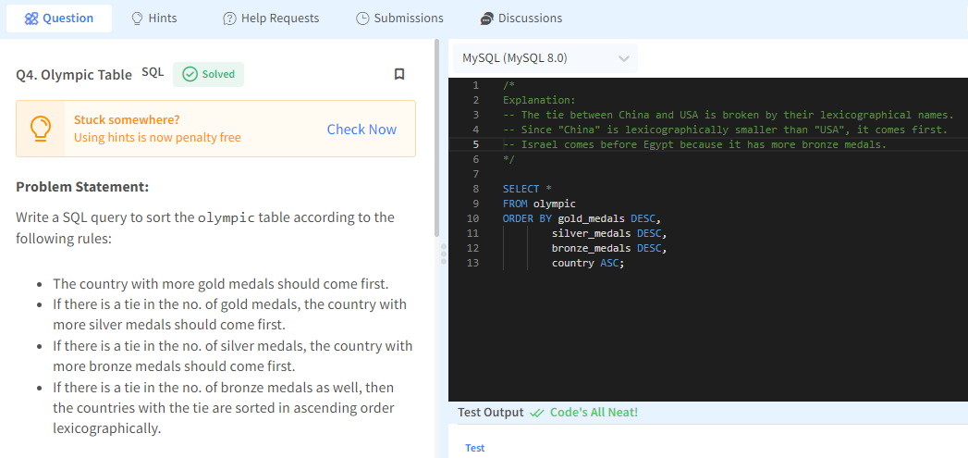

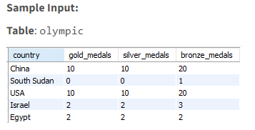 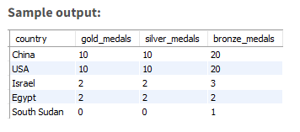

Q5. Movies (Not Boring)

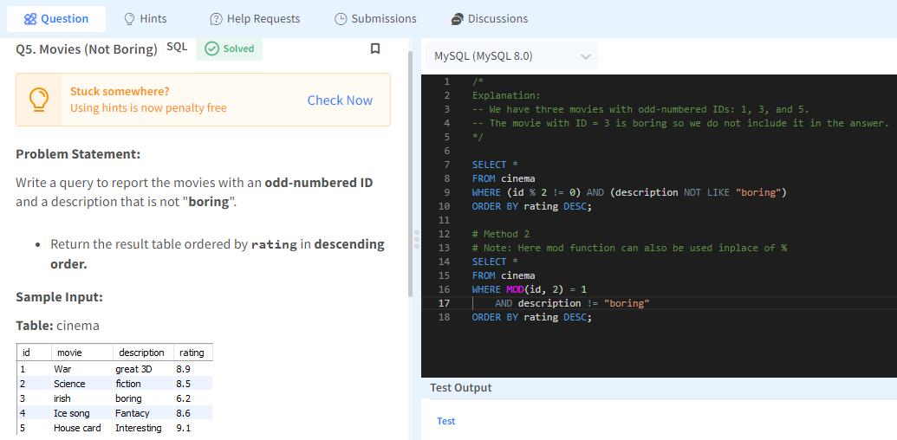

Q6. 2012-2015

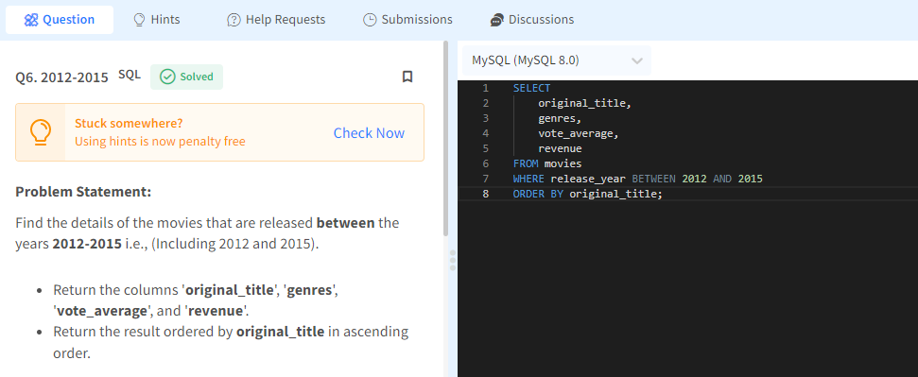

Q7. Low Fat & Recyclable Products

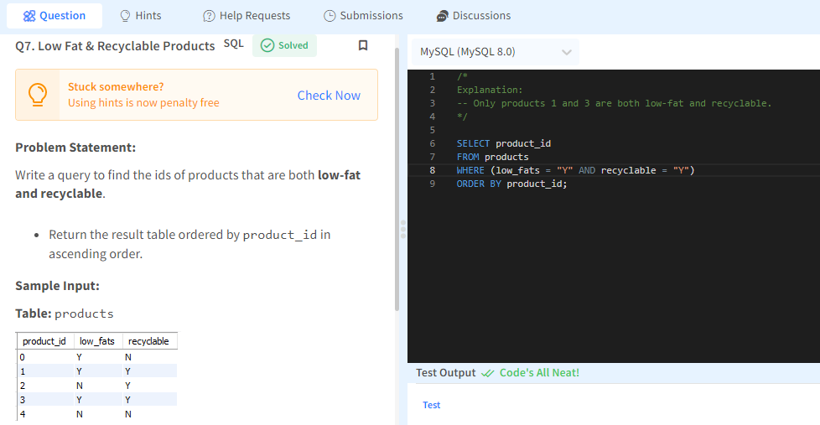

Q8. Problems that are low quality

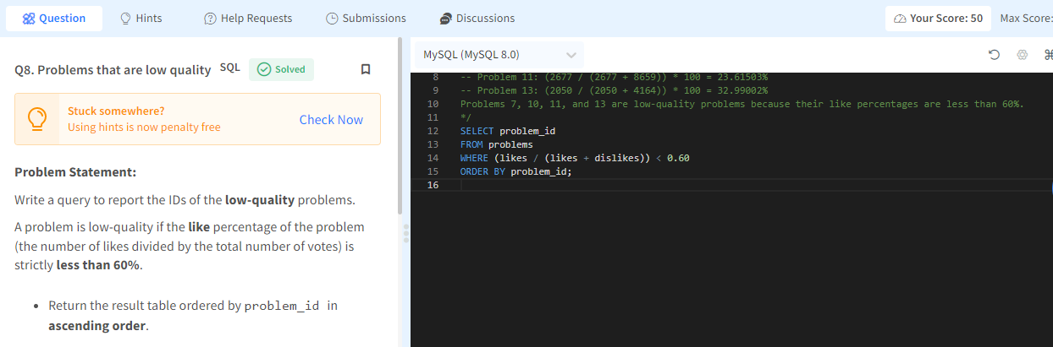

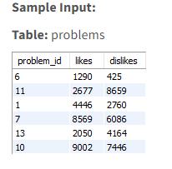 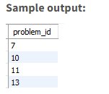

Q9. Letter 'n'

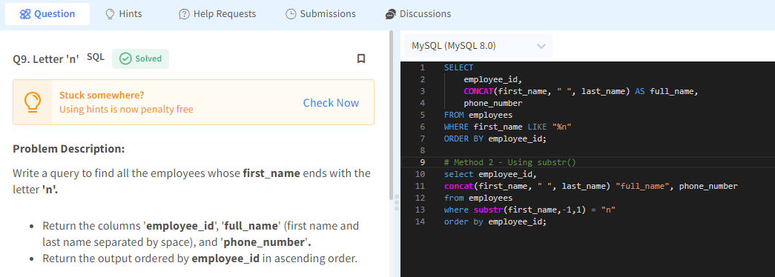

**Dataset Description:**

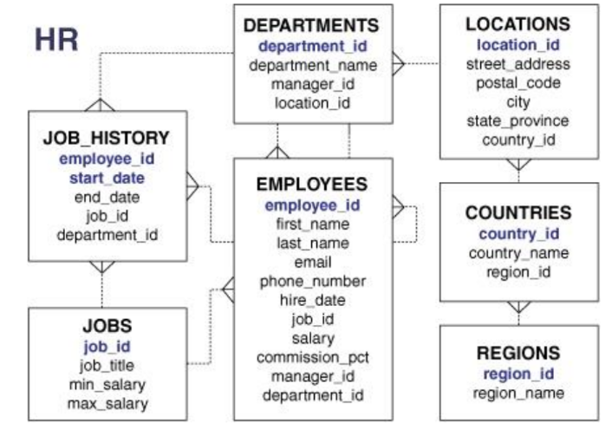

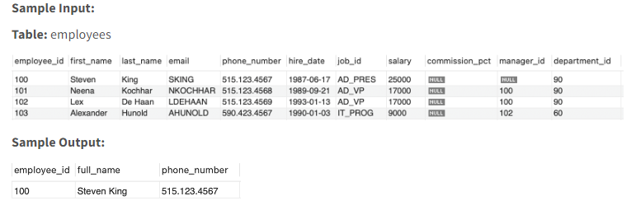

Q10. Keywords

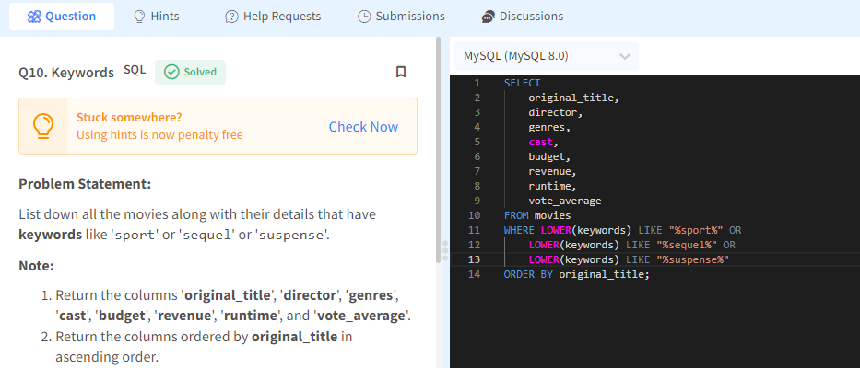

Q11. Concatenate the Name and the Profession

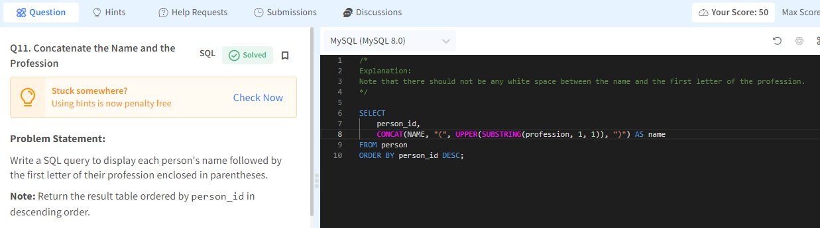

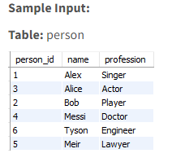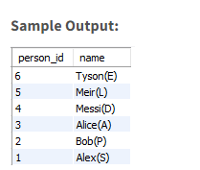

Q12. Movie titles & Tagline

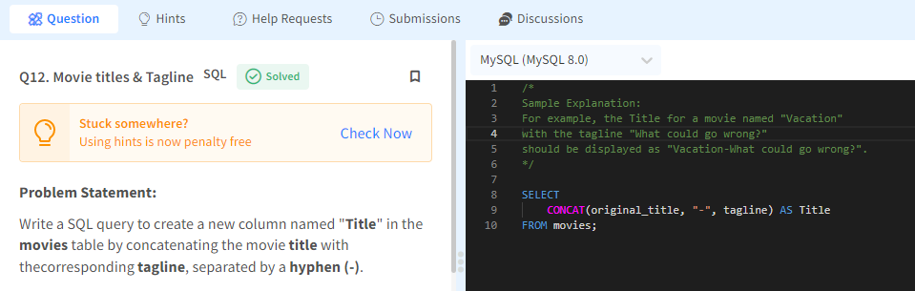

Q13. Salary(5000-10000)

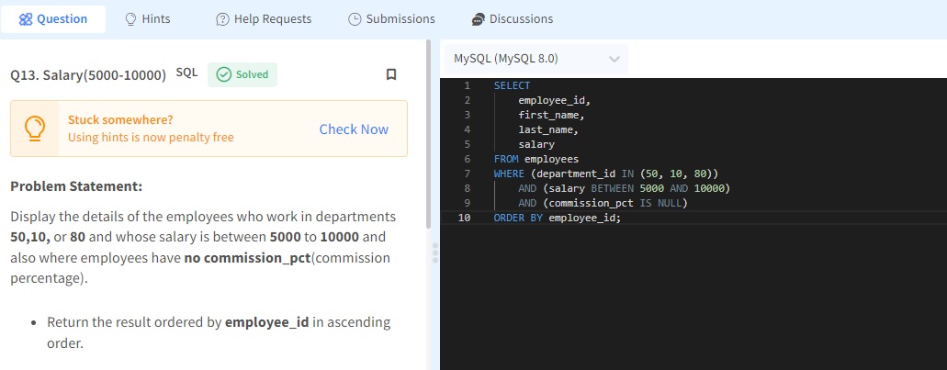

**Dataset Description:**



